Vasukumar Patel 2025T Assignment 4

The Meta Quest 3 comes with two Touch Plus controllers. (see Figure 1).
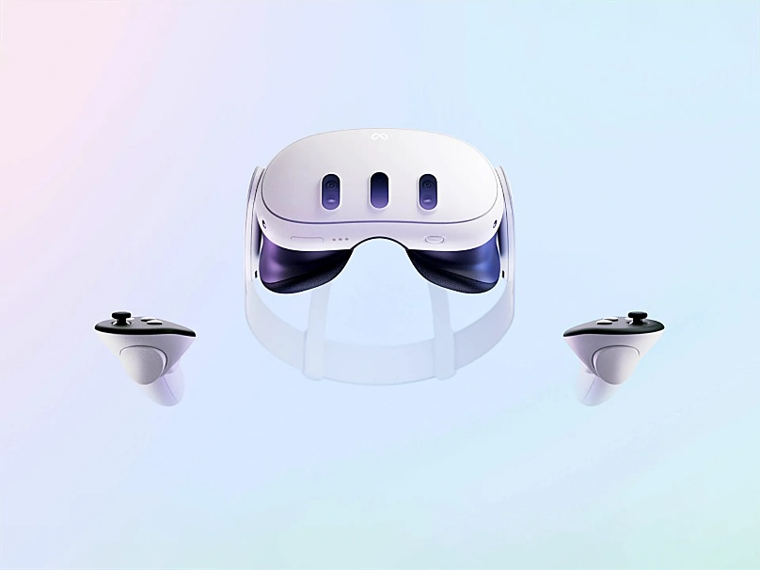
Figure 1: Meta Quest 3 [1]

List of Figures
Figure 1: Meta Quest 3 [1] 1

Bibliography

[1] | B. Ashworth, "The Leaked Quest 3 Headset Video Teases Meta’s VR Ambitions," wired.com, 23 August 2023. [Online]. Available: https://www.wired.com/story/meta-quest-3-headset-video-leak/. [Accessed 11 February 2025].

